Joshua Anaya
CST338
Final MVC Budget Specs

GUI used to find net income, if any for a given month. First I created the View, of the MVC design, which included JPanels, JTextField, and JButtons. One JButton remains hidden until first portion is done, finding net Income. Text to make sure GUI sets up correctly here.
Example below:
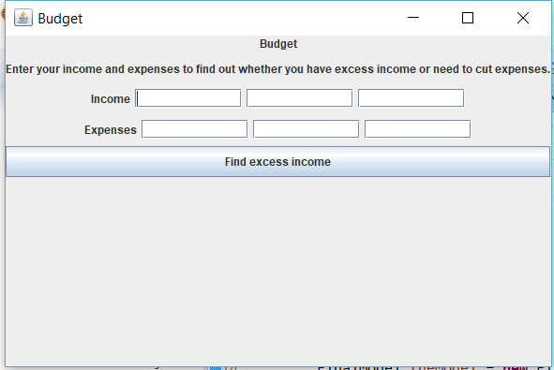

Once that was created, I organized my Model file, of MVC. This file does all the calculations and holds the variables for the calculations. The calculations are to be called by the Controller to either do the calculation or return the value of a variable. Key calculations include addIncome, getIncomeValue, NetIncome, getNetIcnome, MonthstoSave. This is used for both the main budget GUI as well as the new Window Savings Plan GUI. Test for proper calculations here.

The Controller was then designed. This file contains the required code to implement the Model file and view file. The controller calls the View and the Model, and mine also calls the new Window and uses all three components to build the GUI and use the Model calculations. Action listeners are included in the Controller for buttons in the View. The Controller also includes 2 more classes, Months and Save which are used in the Savings Plan GUI to output the months needed to save your net income as well as showing you a monthly count of your savings. Test for the proper output with the net income value. Be sure to make What If button visible only if there is a positive net Income Value.

If income exceeds expenses, a What If button becomes visible at the bottom of the screen.
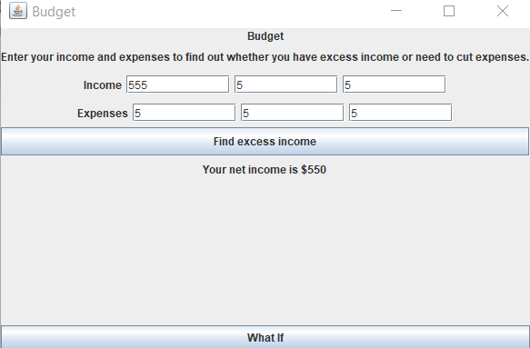

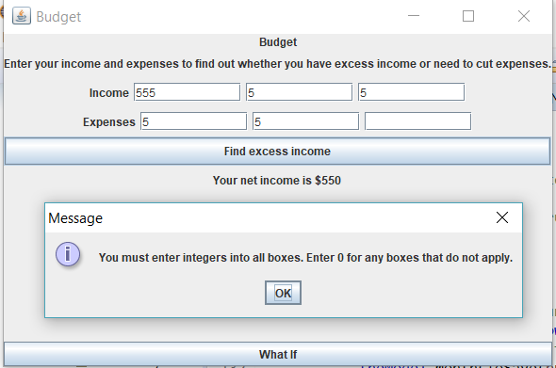
Messages are also set up to catch if a person does not enter a value for all the boxes.

An alternative message was set up if your expenses exceed your income as shown below. This also does not make the What if button visible.
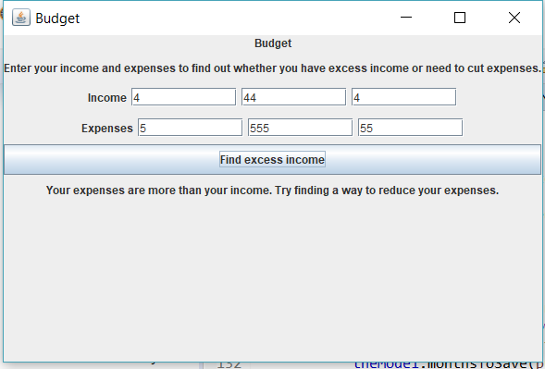

If the net income is available, clicking the What if button opens a new Window with your Net income prepopulated. This was shown in the second picture.

This window calculates the amount of time needed to save enough money for a big expense, with Christmas coming around the corner. Messages will appear if you click the button before entering an amount, if you enter 0, or if you enter an amount below your current net Income. 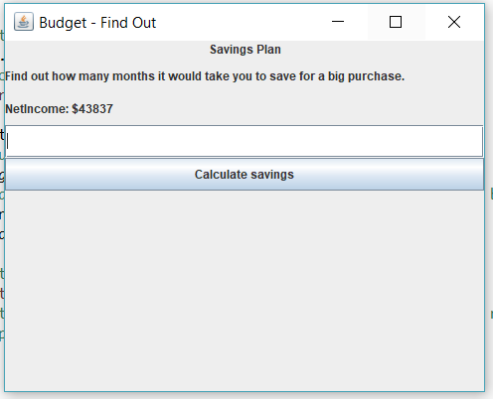
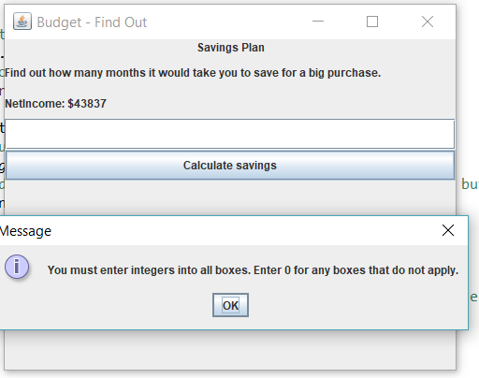
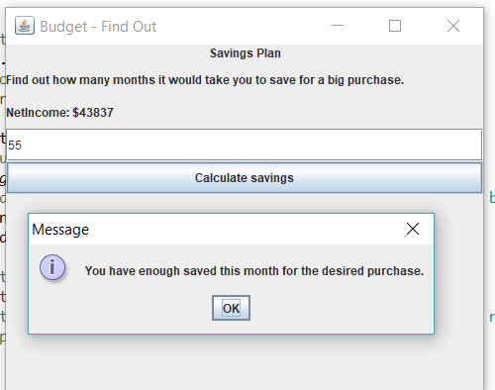

If your purchase value is greater than the net Income, the Months and Save classes will be run to output your months and savings count to the console.
